**Experiment 8**

**Aim:** Write a Shell Script to Swap Two Numbers

**Software:** Ubuntu

**Procedure:**

* Using command #gedit create a file with .sh extension
* Enter the given Shell Script in the file.

firstnumber=12

secondnumber=24

echo "Before Swapping"

echo "First number:$firstnumber"

echo "Second number:$secondnumber"

temp=$firstnumber

firstnumber=$secondnumber

secondnumber=$temp

echo "After Swapping"

echo "First number:$firstnumber"

echo "Second number:$secondnumber"

* Use commands #chmod +x filename.sh to give execution rights to the file.
* Then ./filename.sh to launch the file.
* Finally we get the swapped numbers.

**Output:**

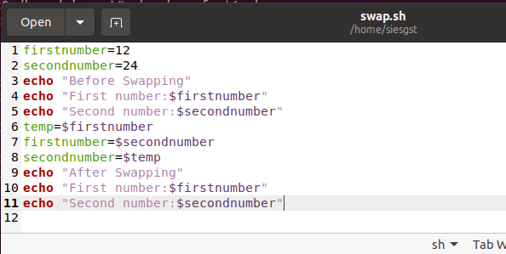

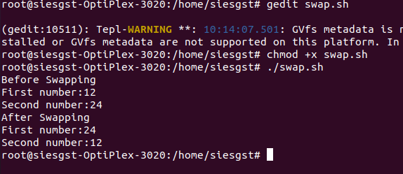

**Conclusion:**

The Shell Script to Swap Two Numbers was performed successfully.